НЕУДАЧНЫЙ ЗАПУСК - ЧЕРЕЗ ПРОКСИ НЕ РАБОТАЕТ - НАДО JSOUP ПОПРАВИТЬ НАВЕРНОЕ!

2018-11-22 13:29:49.514 INFO 31928 --- [nio-8080-exec-1] c.p.s.controller.StartController : Request to StartController method GET

2018-11-22 13:29:50.815 INFO 31928 --- [nio-8080-exec-2] c.p.s.controller.CheckController : Request to ItemCheckController method POST. Try to check user 1955aa@inbox.ru with password 123qwe

2018-11-22 13:29:50.818 INFO 31928 --- [nio-8080-exec-2] c.p.s.controller.CheckController : checkUserAsRegistered - above return statement = new ResponseEntity

2018-11-22 13:32:33.517 INFO 31928 --- [nio-8080-exec-5] c.p.s.controller.CheckController : Request to UserController method POST. Try to get item info with id ODM8949139

2018-11-22 13:32:49.163 ERROR 31928 --- [nio-8080-exec-5] c.p.s.service.impl.ItemServiceImpl : Read timed out

2018-11-22 13:32:49.163 INFO 31928 --- [nio-8080-exec-5] c.p.s.controller.CheckController : findItem - (item = null) = itemBox = htmlManager.getItemCheckBox " "

2018-11-22 13:32:49.163 INFO 31928 --- [nio-8080-exec-5] c.p.s.service.impl.UserServiceImpl : UserServiceImpl.tryToLogin - START

2018-11-22 13:32:51.167 INFO 31928 --- [nio-8080-exec-5] c.p.s.service.impl.UserServiceImpl : UserServiceImpl.tryToLogin - in TRY CLAUSE - responce

2018-11-22 13:33:06.229 ERROR 31928 --- [nio-8080-exec-5] c.p.s.service.impl.UserServiceImpl : Read timed out

2018-11-22 13:33:06.230 INFO 31928 --- [nio-8080-exec-5] c.p.s.service.impl.UserServiceImpl : UserServiceImpl.tryToLogin - RETURN NULL

2018-11-22 13:33:06.230 INFO 31928 --- [nio-8080-exec-5] c.p.s.service.impl.ShopServiceImpl : ShopServiceImpl.getAllShops - START

2018-11-22 13:33:21.327 ERROR 31928 --- [nio-8080-exec-5] c.p.s.service.impl.ShopServiceImpl : Read timed out

2018-11-22 13:33:21.327 INFO 31928 --- [nio-8080-exec-5] c.p.s.service.impl.ShopServiceImpl : ShopServiceImpl.getAllShops - return allShops

2018-11-22 13:33:21.328 INFO 31928 --- [nio-8080-exec-5] c.p.s.controller.CheckController : findItem - above return statement = new ResponseEntity

А ЭТО Я ПРЯМЫМ ПОДКЛЮЧЕНИЕМ - УЖЕ РАБОТАЕТ!!!

2018-11-22 14:49:33.256 INFO 31928 --- [nio-8080-exec-8] c.p.s.controller.StartController : Request to StartController method GET

2018-11-22 14:49:34.542 INFO 31928 --- [nio-8080-exec-9] c.p.s.controller.CheckController : Request to ItemCheckController method POST. Try to check user 1955aa@inbox.ru with password 123qwe

2018-11-22 14:49:34.543 INFO 31928 --- [nio-8080-exec-9] c.p.s.controller.CheckController : checkUserAsRegistered - above return statement = new ResponseEntity

2018-11-22 14:49:38.127 INFO 31928 --- [io-8080-exec-10] c.p.s.

controller.CheckController : Request to UserController method POST. Try to get item info with id ODM8949139

2018-11-22 14:49:41.316 INFO 31928 --- [io-8080-exec-10] c.p.s.

controller.CheckController : findItem - (item != null) = itemBox = htmlManager.getItemCheckBox (item.getItemId(), login, password)

2018-11-22 14:49:41.316 INFO 31928 --- [io-8080-exec-10] c.p.s.

service.impl.UserServiceImpl : UserServiceImpl.tryToLogin - START

2018-11-22 14:49:43.317 INFO 31928 --- [io-8080-exec-10] c.p.s.

service.impl.UserServiceImpl : UserServiceImpl.tryToLogin - in TRY CLAUSE - responce

2018-11-22 14:49:43.874 INFO 31928 --- [io-8080-exec-10] c.p.s.

service.impl.UserServiceImpl : UserServiceImpl.tryToLogin - RETURN SUCCESSFULLY

2018-11-22 14:49:43.874 INFO 31928 --- [io-8080-exec-10] c.p.s.

service.impl.ShopServiceImpl : ShopServiceImpl.getAllShops - START

2018-11-22 14:49:45.313 INFO 31928 --- [io-8080-exec-10] c.p.s.

service.impl.ShopServiceImpl : ShopServiceImpl.getAllShops - return allShops

2018-11-22 14:49:45.551 INFO 31928 --- [io-8080-exec-10] c.p.s.

controller.CheckController : findItem - above return statement = new ResponseEntity

НАШЛИ МАГАЗИНЫ - ЖДЕМ В КАКОМ СДЕЛАТЬ ЗАКАЗ!

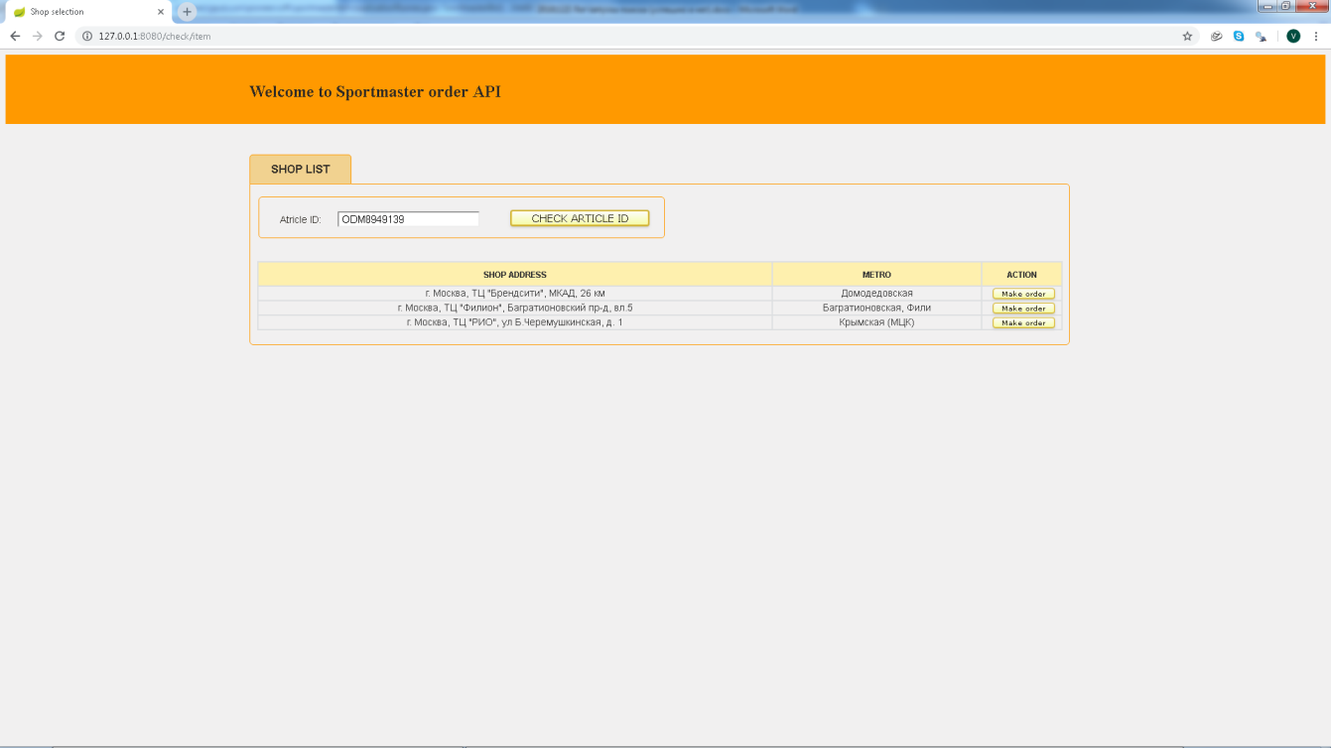

ЖМЕМ "МЭЙК ОРДЕР" и пошло заказывать в СЕЛЕНИУМЕ

2018-11-22 14:56:00.424 INFO 31928 --- [nio-8080-exec-3] c.p.s.

controller.OrderController : Request to UserController method POST. Try to order item ODM8949139 in shop 5575 for account 1955aa@inbox.ru

2018-11-22 14:56:00.427 INFO 31928 --- [nio-8080-exec-3] c.p.s.

service.impl.OrderServiceImpl : OrderServiceImpl.makeOrder - START

2018-11-22 14:56:00.439 INFO 31928 --- [nio-8080-exec-3] c.p.

sportmasterbot.util.WebDriverUtil : WebDriverUtil.getWebDriver - START

Starting ChromeDriver 2.42.591088 (7b2b2dca23cca0862f674758c9a3933e685c27d5) on port 22646

Only local connections are allowed.

2018-11-22 14:56:08.160 INFO 31928 --- [ null to remote] o.o.

selenium.remote.ProtocolHandshake : Detected dialect: OSS

2018-11-22 14:56:10.204 INFO 31928 --- [nio-8080-exec-3] c.p.

sportmasterbot.util.WebDriverUtil : WebDriverUtil.getWebDriver - RETURN DRIVER

2018-11-22 14:58:05.092 INFO 31928 --- [nio-8080-exec-3] c.p.s.

service.impl.ShopServiceImpl : ShopServiceImpl.getAllShops - START

2018-11-22 14:58:05.918 INFO 31928 --- [nio-8080-exec-3] c.p.s.

service.impl.ShopServiceImpl : ShopServiceImpl.getAllShops - return allShops

Order was not created

НЕ УВИДЕЛ ЗАКАЗА (БЫЛИ В КОРЗИНЕ ДРУГИЕ ВЕЩИ ТОЖЕ)!!! ПРОВЕРЯЕМ - ПЕРЕДЕЛЫВАЕМ!!! СТОП

ЗАХОД НОМЕР 2

2018-11-22 15:08:12.363 INFO 25176 --- [ main] s.b.c.e.t.TomcatEmbeddedServletContainer : Tomcat started on port(s): 8080 (http)

2018-11-22 15:08:12.368 INFO 25176 --- [ main] c.p.sportmasterbot.ApplicationRunner : Started ApplicationRunner in 12.544 seconds (JVM running for 14.728)

2018-11-22 15:08:44.618 INFO 25176 --- [nio-8080-exec-1] o.a.c.c.C.[Tomcat].[localhost].[/] : Initializing Spring FrameworkServlet 'dispatcherServlet'

2018-11-22 15:08:44.619 INFO 25176 --- [nio-8080-exec-1] o.s.web.servlet.DispatcherServlet : FrameworkServlet 'dispatcherServlet': initialization started

2018-11-22 15:08:44.653 INFO 25176 --- [nio-8080-exec-1] o.s.web.servlet.DispatcherServlet : FrameworkServlet 'dispatcherServlet': initialization completed in 34 ms

ЗАШЛИ НА ГЛАВНУЮ СТРАНИЦУ!

2018-11-22 15:08:44.761 INFO 25176 --- [nio-8080-exec-1] c.p.s.controller.CheckController : Request to ItemCheckController method POST. Try to check user 1955aa@inbox.ru with password 123qwe

2018-11-22 15:08:44.761 INFO 25176 --- [nio-8080-exec-1] c.p.s.controller.CheckController : checkUserAsRegistered - above return statement = new ResponseEntity

ВЫБРАЛИ ТОВАР ПО КОДУ И НАЖАЛИ ПОИСК!

2018-11-22 15:08:57.463 INFO 25176 --- [nio-8080-exec-5] c.p.s.controller.CheckController : Request to UserController method POST. Try to get item info with id ODM8949139

2018-11-22 15:09:05.184 INFO 25176 --- [nio-8080-exec-5] c.p.s.controller.CheckController : findItem - (item != null) = itemBox = htmlManager.getItemCheckBox (item.getItemId(), login, password)

2018-11-22 15:09:05.185 INFO 25176 --- [nio-8080-exec-5] c.p.s.service.impl.UserServiceImpl : UserServiceImpl.tryToLogin - START

2018-11-22 15:09:07.188 INFO 25176 --- [nio-8080-exec-5] c.p.s.service.impl.UserServiceImpl : UserServiceImpl.tryToLogin - in TRY CLAUSE - responce

2018-11-22 15:09:07.865 INFO 25176 --- [nio-8080-exec-5] c.p.s.service.impl.UserServiceImpl : UserServiceImpl.tryToLogin - RETURN SUCCESSFULLY

2018-11-22 15:09:07.866 INFO 25176 --- [nio-8080-exec-5] c.p.s.service.impl.ShopServiceImpl : ShopServiceImpl.getAllShops - START

2018-11-22 15:09:09.632 INFO 25176 --- [nio-8080-exec-5] c.p.s.service.impl.ShopServiceImpl : ShopServiceImpl.getAllShops - return allShops

2018-11-22 15:09:09.632 INFO 25176 --- [nio-8080-exec-5] c.p.s.service.impl.ShopServiceImpl : ShopServiceImpl.filterShopsByAvailableItem - START

2018-11-22 15:09:10.067 INFO 25176 --- [nio-8080-exec-5] c.p.s.controller.CheckController : findItem - above return statement = new ResponseEntity

ПОЛУЧИЛИ РЕЗУЛЬТАТЫ ПОИСКА ПО МАГАЗИНАМ!!!

ЖМЕМ НА ЗАКАЗ!!!

2018-11-22 15:10:15.423 INFO 25176 --- [nio-8080-exec-7] c.p.s.controller.OrderController : Request to UserController method POST. Try to order item ODM8949139 in shop 5575 for account 1955aa@inbox.ru

2018-11-22 15:10:15.424 INFO 25176 --- [nio-8080-exec-7] c.p.s.controller.OrderController : orderService.makeOrder( ODM8949139, 5575, 1955aa@inbox.ru, 123qwe)

2018-11-22 15:10:15.424 INFO 25176 --- [nio-8080-exec-7] c.p.s.service.impl.OrderServiceImpl : OrderServiceImpl.makeOrder - START (!!!!!!!!!!!!!!!)

2018-11-22 15:10:15.425 INFO 25176 --- [nio-8080-exec-7] c.p.sportmasterbot.util.WebDriverUtil : WebDriverUtil.getWebDriver - START (headless mode)

Starting ChromeDriver 2.42.591088 (7b2b2dca23cca0862f674758c9a3933e685c27d5) on port 27864

Only local connections are allowed.

2018-11-22 15:10:17.951 INFO 25176 --- [ null to remote] o.o.selenium.remote.ProtocolHandshake : Detected dialect: OSS

2018-11-22 15:10:27.985 INFO 25176 --- [nio-8080-exec-7] c.p.sportmasterbot.util.WebDriverUtil : WebDriverUtil.getWebDriver - RETURN DRIVER

2018-11-22 15:12:25.849 INFO 25176 --- [nio-8080-exec-7] c.p.s.service.impl.ShopServiceImpl : ShopServiceImpl.getAllShops - START

2018-11-22 15:12:26.711 INFO 25176 --- [nio-8080-exec-7] c.p.s.service.impl.ShopServiceImpl : ShopServiceImpl.getAllShops - return allShops

2018-11-22 15:12:38.211 INFO 25176 --- [nio-8080-exec-7] c.p.s.controller.OrderController : orderService.makeOrder - PASSED

В КОРЗИНЕ ТОВАР ЕСТЬ - НО ЗАКАЗА НЕ ПРОШЛО! ХЭДЛЕСС РЕЖИМ РАБОТАЕТ!!!